|  |  |
| --- | --- |
| ENGR 325 Lab 1  Building Systems with Quartus’ Qsys Tool | Abstract  This lab was focused on generating a complex system using the Altera Qsys and using the Signal Tap Logic Analyzer tool.  Daniel Ackuaku |

Below is a copy of the top level VHDL code for Lab1:

LIBRARY ieee;

USE ieee.std_logic_1164.ALL;

USE ieee.std_logic_unsigned.ALL;

ENTITY Lab1 IS

PORT (

CLOCK_50 : IN STD_LOGIC;

GPIO_0 : OUT STD_LOGIC_VECTOR (0 DOWNTO 0);

KEY : IN STD_LOGIC_VECTOR (0 DOWNTO 0);

UART_RXD : IN STD_LOGIC;

UART_TXD : OUT STD_LOGIC;

LCD_DATA : INOUT STD_LOGIC_VECTOR (7 DOWNTO 0);

LCD_ON : OUT STD_LOGIC;

LCD_BLON : OUT STD_LOGIC;

LCD_EN : OUT STD_LOGIC;

LCD_RS : OUT STD_LOGIC;

LCD_RW : OUT STD_LOGIC

);

END Lab1;

ARCHITECTURE Lab1_rtl OF Lab1 IS

component nios_system is

port (

clk_clk : in std_logic := 'X'; -- clk

reset_reset_n : in std_logic := 'X'; -- reset_n

rs232_RXD : in std_logic := 'X'; -- RXD

rs232_TXD : out std_logic; -- TXD

lcd_DATA : inout std_logic_vector(7 downto 0) := (others => 'X'); -- DATA

lcd_ON : out std_logic; -- ON

lcd_BLON : out std_logic; -- BLON

lcd_EN : out std_logic; -- EN

lcd_RS : out std_logic; -- RS

lcd_RW : out std_logic -- RW

);

end component nios_system;

component ClockDividerCircuit is

port (

Clock : in std_logic;

Reset_n : in std_logic;

ClockOut : out std_logic

);

end component ClockDividerCircuit;

BEGIN

-- mapping the nios_system

u0 : component nios_system

port map (

clk_clk => CLOCK_50, -- clk.clk

reset_reset_n => KEY(0), -- reset.reset_n

rs232_RXD => UART_RXD, -- rs232.RXD

rs232_TXD => UART_TXD, -- .TXD

lcd_DATA => LCD_DATA(7 DOWNTO 0), -- lcd.DATA

lcd_ON => LCD_ON, -- .ON

lcd_BLON => LCD_BLON, -- .BLON

lcd_EN => LCD_EN, -- .EN

lcd_RS => LCD_RS, -- .RS

lcd_RW => LCD_RW -- .RW

);

-- mapping the clock divider circuit

ClkDiv : component ClockDividerCircuit

port map (

Clock => CLOCK_50,

Reset_n => KEY(0),

ClockOut => GPIO_0(0)

);

END Lab1_rtl;

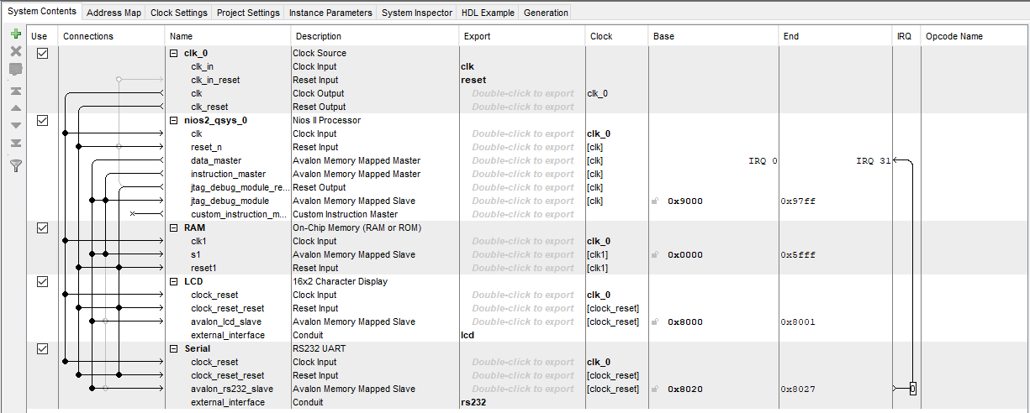

Figure 1Screen capture of the final Qsys configuration page.

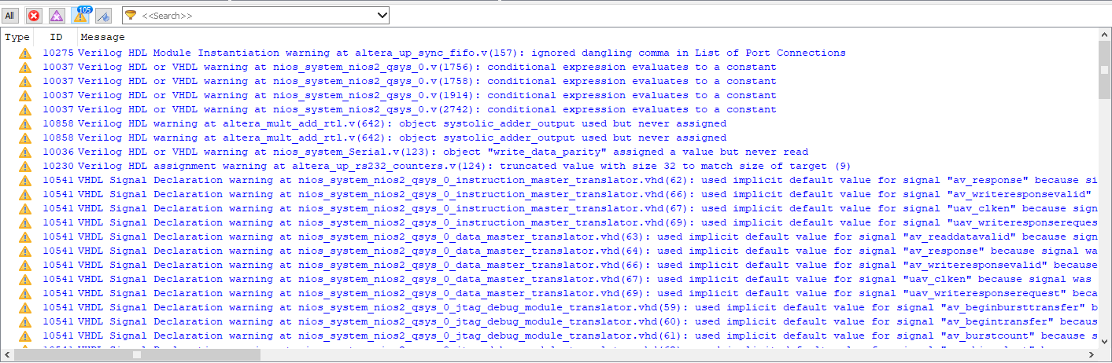

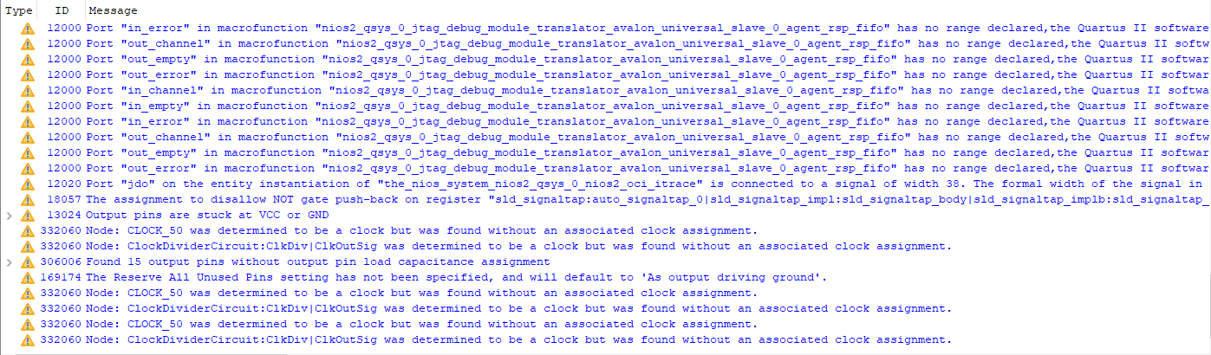Figure 2&3 Screen Capture of all Compilation warnings for the top-level design.